**Task no 1:**

**Perform the following task on the Excel sheet provided given below for performing the given task in this lab.**

**SOLUTION:**

**1-Insert a Pivot Table for the given data.**

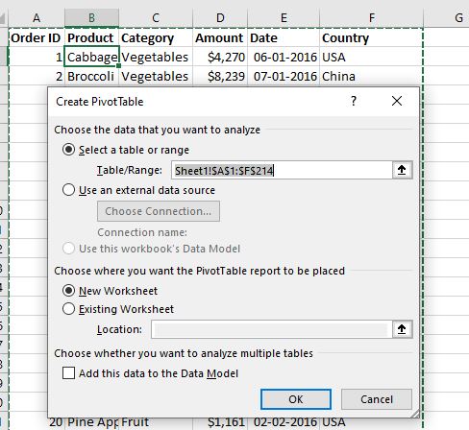

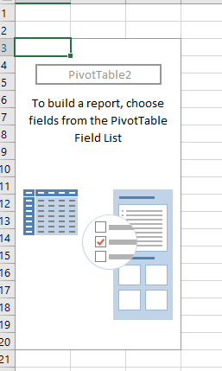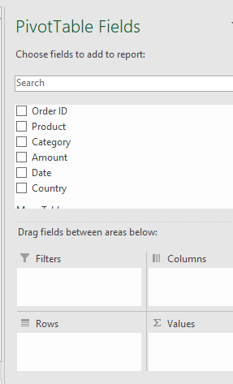

**2-Find out which products do we export the most to USA?**

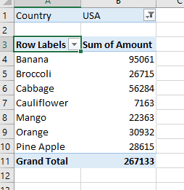

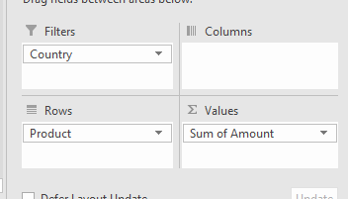

**3-Find the summary calculation "Maximum" and save the results.**

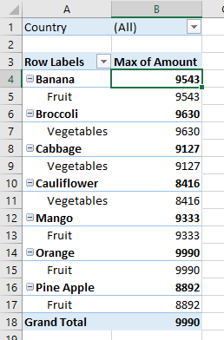

**4-Construct a 2-dimensional Pivot Table.**

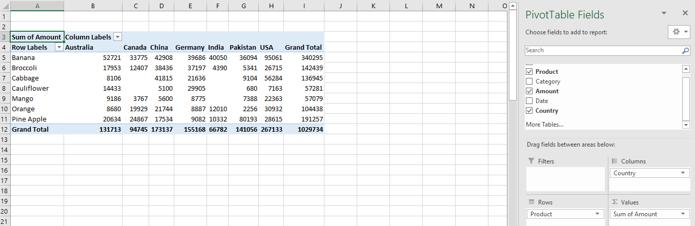

**5-Insert the pivot Chart for 2-dimensional Pivot Table.**

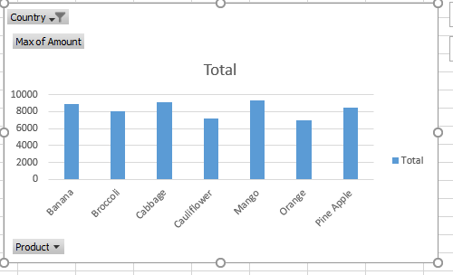

**6-Use the country filter that only show the total amount of each product exported to the China in Pivot Chart.**

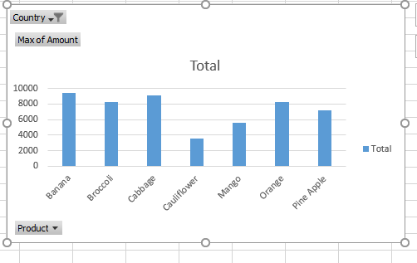

**7-Use the Category filter to only show the vegetables exported to each country.**

